Furniture Shop Management System
ABSTRACT
In this title "Furniture Shop Management System" which is a shop management system to manage furniture shop business and it is implemented with inventory management. There are 5 main modules in this system, which are user profile management, purchase management, sales management stock management and Billing management. The problem statements of this thesis are the current management system does not have well inventory management. There does not have the facilities to handle the receipts and issues of stock. The second problem is this current management system is manually system which records the information of staff and supplier, stock record, and sales report in paperwork. There are two (2) objectives of this thesis, which are to develop a systematic inventory management of Furniture Shop Management System (FSMS) and to provide a good storage stock and retrieve data information in this furniture shop management system. This thesis is discussed on how this furniture shop management system to be implemented, the tools and programming languages used, and the resources needed in developing this system. Prototyping is used to develop this project. The strength of Furniture Shop Management System is implemented with the well inventory management to manipulate the inventory of the shop.

SYSTEM SPECIFICATION
HARDWARE SPECFICATION:
- Processor : P 4 700 GHz.
- RAM : 4 GB RAM
- Hard Disk Drive : 180 GB

SOFTWARE SPECIFICATION:

  - Operating System : Windows 7/8/10
  - Front End : JAVA
  - Back End : SQL

SYSTEM STUDY
EXISTING SYSTEM:
This existing system is fully handled by man power, which takes lot of paper based. So, it’s a waste of money for the furniture shop manager. Purchased and stocked details are very risk to handle by the shop manager. It takes too much time for calculating the amount.
DRAWBACKS:
The existing system has the following drawbacks.
- Does not keep track of purchase.
- Does not keep track of stock.
- Very risk to calculate billing details manually.

PROPOSED SYSTEM:
The proposed system of ‘Furniture management system’ is that reduce these kinds of issues, which may help to develop the furniture shop. Every product should be register when purchasing the product same as every product should be mentioned before sales the product
FEATURES:
- Helps furniture shops to automate furniture selling.
- Purchase and sales report details.
- Provide billing details systematically

MODULES:
- Furniture Registration
- Employee Registration
- Customer Registration
- Purchase Management
- Sales Management
- Billing Management
MODULES
- Furniture Registration
Shop owner has registered the furniture details in this module. In this module will used to search and find the furniture module.
- Employee Registration
Employees are registered by admin, every employees have unique username and password, once employees have got access to login then they can provide entry to purchase and sales.
- Customer Registration
This module collects all the information about the customer, when customer billed first time, we just collect the information for the future purpose.

- Purchase Management:
Every product has purchased and added in this module. Which could be added the purchased the items will be adding the purchase module.
- Sales Management
This module has used to register the product details before selling. So we can identify the stock of product and billing details.
- Billing Management
We can calculate billing details based on sales details. This module will generate billing details based on its sales.

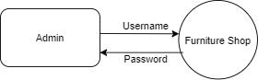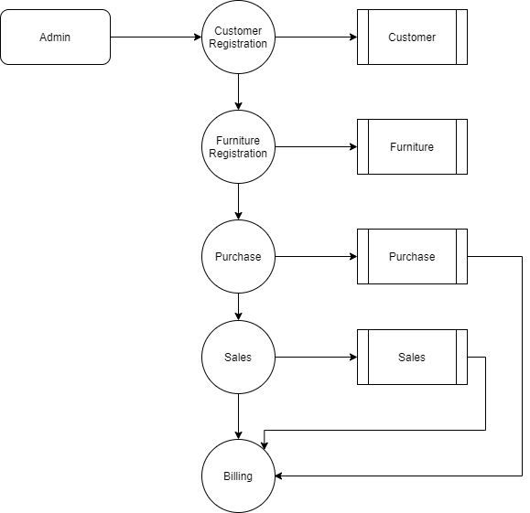

TABLE NAME: ADMIN

FIELD | DATA TYPE | SIZE | CONSTRAINT
Admin id | Int | 10 | Primary key
Username | Varchar | 30 | Not null
password | Varchar | 30 | Not null

TABLE NAME: CUSTOMER

FIELD | DATA TYPE | SIZE | CONSTRAINT
Customer id | Int | 10 | Primary key
Name | Varchar | 20 | Not null
Mobile | Int | 10 | Not null
Alternate | Int | 10 | Not null
Address | Varchar | 30 | Not null
Gender | Varchar | 10 | Not null

TABLE NAME: FURNITURE

FIELD | DATA TYPE | SIZE | CONSTRAINT
Furniture Id | Int | 10 | Primary key
Company | Varchar | 30 | Not null
Model | Varchar | 30 | Not null
Price | int | 10 | Not null

TABLE NAME: PURCHASE

FIELD | DATA TYPE | SIZE | CONSTRAINT
Purchase id | Int | 10 | Primary key
Product id | Int | 10 | Foreign key
Quantity | Int | 5 | Not null
Details | Varchar | 30 | Not null
Date | date | 10 | Not null

TABLE NAME: SALES

FIELD | DATA TYPE | SIZE | CONSTRAINT
Sales id | Int | 10 | Primary key
Customer id | Int | 10 | Foreign key
Product id | Int | 10 | Foreign key
quantity | int | 5 | Not null

